Nepal College of Information Technology
Assessment Fall 2013
Program : BE Time : 3 hrs
Semester : Fall (III) FM : 100
Subject : Logic Circuits PM : 50

- Candidates are requested to give their answer as far as practicable in their own words.
- The figure in the margin indicates the full marks
- Attempt ALL question

1. a) Perform the following conversion: 5
i) (623)₈ =(….)₁₀=(….)₂
ii) (24C5)₁₆ =(….)₂=(….)₁₀
b) Perform the subtraction with the following decimal and binary numbers using 9’s and 1’s 5 complement respectively.
i) 2659-7276(using 9‘s complement )
ii) 1101100-11100010(using 1‘s complement )
c) Show that the dual of X-OR is equal to its complement. 5
2. a) A logic circuit implements Boolean function 7
F=A’C+AC’D’
It is found in the circuit that the circuit i/p combination A=C=1 can never occur. Using k-map with proper don’t care conditions, find a simpler expression for F and implement it using NAND gates only assuming that complemented form of the variables not available.
b) Simplify the following Boolean function in SOP & POS form: 8
F(A,B,C,D)= Ʃ(6,7,9,12,13,14,15)
D(A,B,C,D)= Ʃ(3,5,8)
3. a) Simplify the following functions to minimum no. of literals using Boolean function: 8
i) (x+y)(x’+z)(y+z)
ii) xyz+x’y’+xyz’
b) Implement the full adder circuit using two 4×1 MUX. 7
4. a) Design a combinational circuit that accepts a three-bit number and generates an output binary number equal to the square of the input. 8
b) Derive a PLA program table for 3 bit parity generator. 7
5) a) Design a code conversion circuit that converts BCD to excess-3 code. 10
b) what are the steps involved in the design procedure of sequential logic circuit. 5
6) a) Draw a logic diagram, characteristic table and derive a characteristic equation of clocked SR Latch. What is the disadvantage of latch and how can it be overcome? 7
b) Realize the following state diagram into the circuit using T flipflop. 8
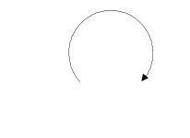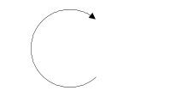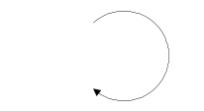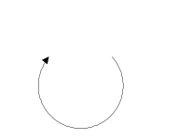
0
0
000
10
0
1
01
11
1
1
0
1

7) Write short notes on(Any two) (5*2)
a) state table and state diagram
b) ROM and its types
c) Alphanumeric code

